Handout 6

Have got/ has got

Look and make up sentence. Use have got/ has got.
Carol/a bottle of perfume | Your friends/brown eyes | Benny/an e-mail message
____________________ | ____________________ | _____________________
 |  | 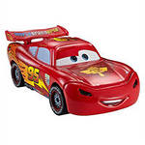
His brother/a costume/not | They/an interesting game | Ted’s dad/a red car
____________________ | ____________________ | _____________________
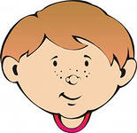 |  | 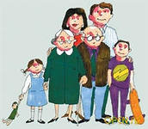
Peter/dark hair/blue eyes | Jim and Sally/a computer/not | My family/friends/Paris
____________________ | ____________________ | _____________________
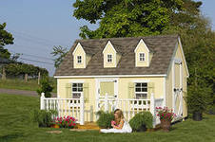
We/a house/Bond street | Ellie/fair hair? | I/Genie/not
____________________ | ____________________ | _____________________
 | 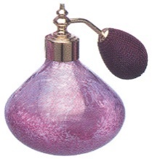 | 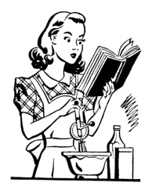
Katie’s sister/jumping beans/not | You/a bottle of perfume? | My mother/long hair.
____________________ | ____________________ | _____________________

